We focus on the medium product backlog items first and we follow the estimates.

Laura:

9 - As a cashier, I want to accept an order when a payment is in cash so that it will appear for baristas.‘

Kamil:

8 - As the display monitor, I want to fetch and display both pending and completed orders for customers to know the status of their order.

Robert:

10 - As a customer, I want to be prompted for extras to put in my drink (like syrups) so that my coffee will be more tasteful.

12 - As a customer, I want to be able to cancel my order at any time so that I am free to make that decision.

**SPRINT GOAL:** Two or three new windows - for a cashier, Display view, view or prompt for extras,

| PB-ID | ID | Task Title | Responsible | Estimate (hours) | Status |
| --- | --- | --- | --- | --- | --- |
| 8 | 1 | Design and Create Display View | Kamil | 8 | Completed |
| 8 | 2 | Implement VC and VM for Display | Kamil | 8 | Completed |
| 8 | 3 | Document and test Display | Kamil + Robert | 16(8*2) | Completed |
| 9 | 4 | Design and Create Cashier View | Laura | 4 | Completed |
| 9 | 6 | Implement VC and VM for Cashier View | Laura | 8 | Completed |
| 9 | 5 | Document and test Cashier | Laura | 4 | Completed |
| 9 | 7 | Implement VC and VM for - access keys | Daniel | 16 | Completed |
| 10 | 8 | Implement ExtraView with four different types | Robert+Kamil | 14 | Completed |
| 10 | 9 | Design ExtraView | Robert+Kamil | 2 | Completed |
| 10 | 10 | Document and test Extra | Robert | 2 | Completed |
| 12 | 11 | Implement the quit button | Daniel | 10 | Completed |

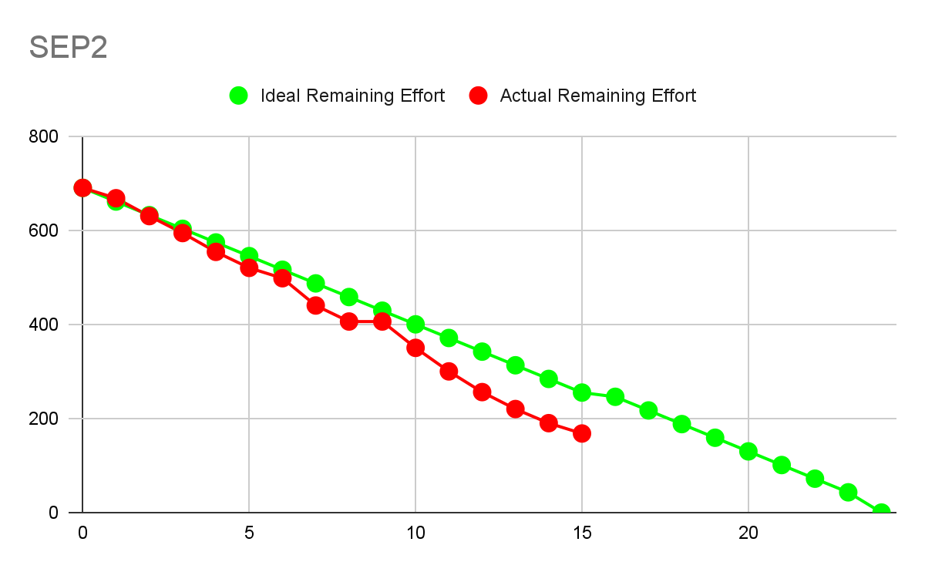

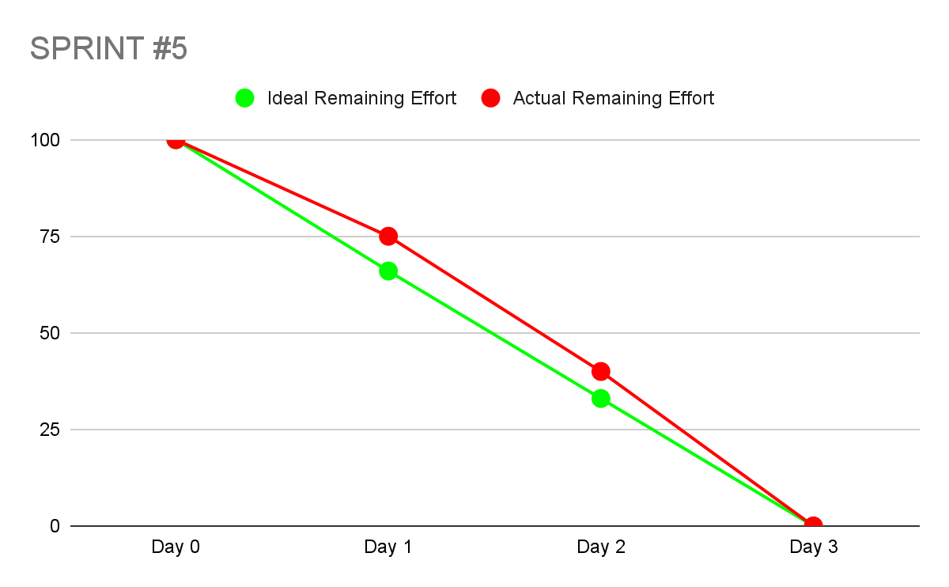

NOTES: OrderList type is not existing and it is in the Model interface,

Receive order in DAO should return an int representing the id of the order so that customer knows which order id is his, BaristaVM still has dependency with utility package